Understanding causes of Injury Severity in Car Accidents

MSIS 5633 BITT TERM PROJECT

TEAM MEMBERS:

SAUMITRA JOSHI (A20094307)   
ANKIT SINGH (A20111177)   
MADHAV SHARMA (A11758147)   
SOUPARNA LODH (A20101631)

# Executive Summary

The purpose of this project is to build a predictive model in KNIME to understand the causes of Injury severity in Car Crash Accidents. The three-prediction model we have created here are – Decision Tree, Random Forest and Artificial Neural Network (ANN) model. For this project, we were given four different SAS files – Accident, Vehicle, Person and Distraction. All of these files cover some of different aspects of car accidents. Our main objective is to use these models to see which model works best to predict the injury severity and understand the causes of accidents. The analysis of ours is going to help the USA transportation industry to come up with proper actions to prevent these car accidents. Our main stakeholders of this project is – NHTSA, US Law Enforcement Officers, First Responders and Vehicle Manufacturers.

# Business Understanding

“Save lives, prevent injuries, reduce vehicle-related crashes.” – Mission (NHTSA)

Transportation is widely considered as the nervous system of economy. Road transportation has been very critical part of evolution of our civilizations and has been essential for trade, cultural exchange, tourism, etc. The USA road transportation industry is worth more than $3 trillion. Road safety continues to be an issue of immense importance. Though things have become better with time and technological advances, road accidents still cost the US an average of $870 billion every year. Car crashes CDC lists unintentional accidents as 3rd leading cause of unnatural death in the US. Car Accidents are leading cause of unintentional accidental deaths. There has been more than 5 million road accidents every year in the last decade. According to NHTSA, more than 90 people die in motor vehicle accidents every day. These deaths occur due to fatal injuries that people involved in these vehicles suffer. As it can be inferred from Figure 1, the number of deaths caused in car crashes has been steadily declining. This change is coming about due to improvements in road infrastructure and advances in safety features of automobiles. The regulations have also played an important role in getting the fatality rate down.

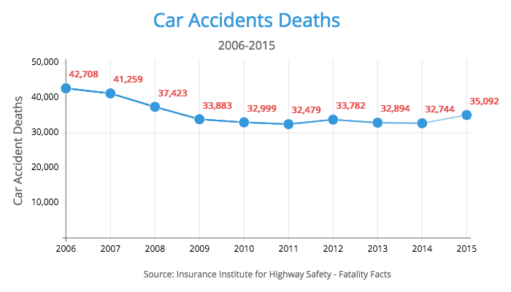

In order to continue this mission, we analyze the data provided by National Highway Traffic Safety Association. This data is collected from thousands of accidents all over the USA*.* This data can be instrumental in narrowing down causes of severe injuries during car crashes. These insights can be used by industry leaders to focus on safety innovation and government for making data driven policy based decisions. Classify injury severity and drilling down on the factors associated with a specific injury class.

# Data Understanding

For this project, we were given four different dataset; all of them were of SAS files. These four datasets cover four different aspects of car accidents. These are – Accidents, Person, Vehicle and Distractions. Accident file covers all the accidents happened throughout the history in United States. Person files consists all the details of persons who were involved in the accident. Vehicle file consists the details of the vehicles got involved in the accidents and The Distraction file consists different kind of distractions driver faced while driving, which led to happen the accident.

Below are the details of the four files:

**Accident:**

Consists data about all the accidents.

CASENUM is the unique identifier here.

**Person:**

Contains data about motorist and non-motorist people.

CASENUM, VEH_NO, and PER_NO are the unique identifiers.

**Vehicle:**

Contains information about the motor vehicle. Also contains data about driver and pre-crash data.

CASENUM and VEH_NO are the unique identifiers.

**Distract:**

Contains data about each driver distraction.

CASENUM, VEH_NO, and MDRDSTRD are the unique identifiers.

For our analysis, we chose INJ_SEV column as our target variable.

* 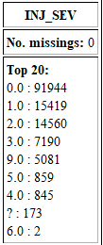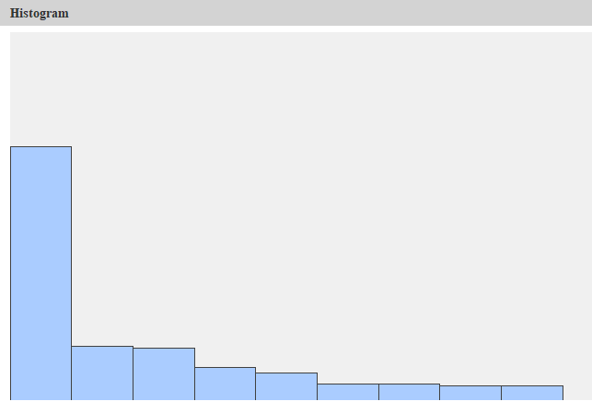INJ_SEV
  + 0 – No apparent Injury
  + 1 – possible injury
  + 2 – suspected minor injury
  + 3 – suspected serious injury
  + 4 – fatal injury
  + 5 – injured, severity Unknown
  + 6 – Died prior to crash
  + 9 – Unknown

We can see INJ_SEV column has eight different categories, where most of the records are with no apparent injury (almost 92000). So clearly, this target column is majorly biased.

# Data Preprocessing

Data Preprocessing is one of the main step in CRISP-DM process. According to the experts, for any Data Mining or Analytics project, Data preprocessing takes 80% of the whole project timeline. Without proper data preprocessing, it is not possible to build a good model.

For our Car Accidents dataset analysis, we did many data preprocessing techniques.

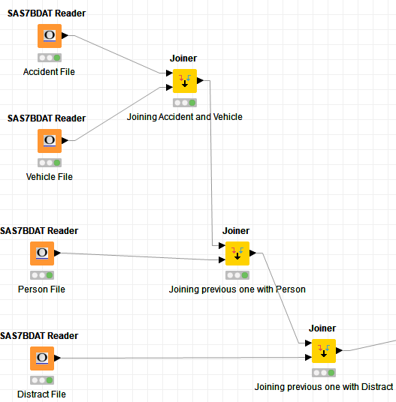First, we consolidated four SAS files to one single file. For that, we used joiner node to join the files.

We have used SAS7BDAT reader to read these SAS files. Then used joiner node to join the files. For four files, we have used three-joiner node to get one single file.

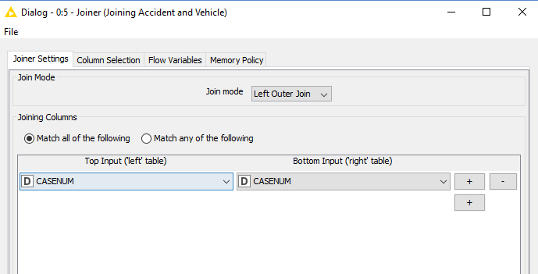

First, we have joined Accident and Vehicle files on CASENUM column.

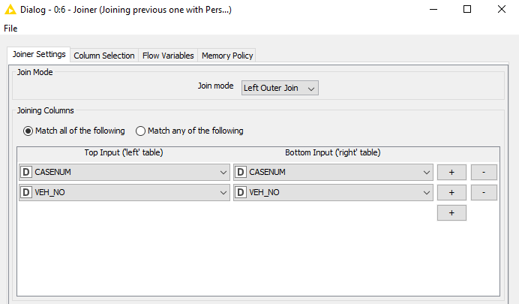Then we joined the joined file of accident and vehicle with Person file.

The condition of join is both CASENUM and VEH_NO columns.

Then we joined the joined file of Accident, Person and Vehicle with Distract file.

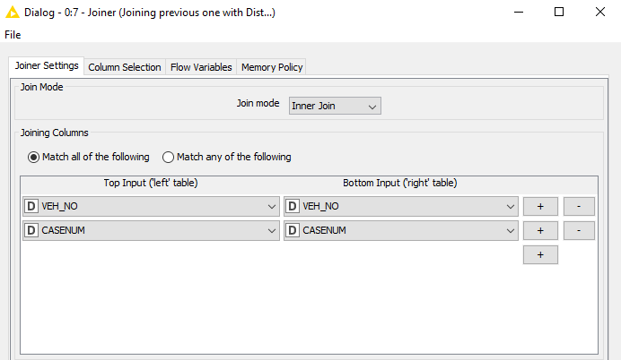The condition was on VEH_NO and CASENUM columns.

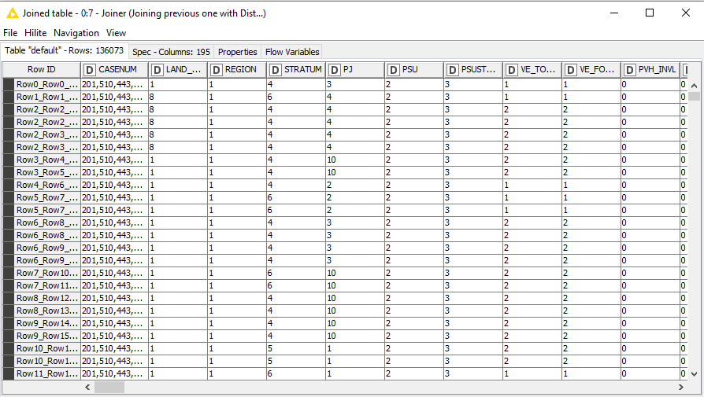After joining these four files, we got a single file, which has 136073 rows and 195 columns.

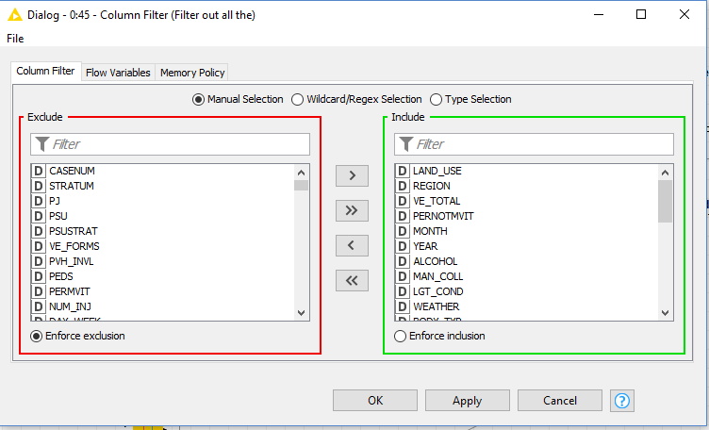Then we have used Column filter to eliminate some of the useless columns, which we do not need in our analysis.

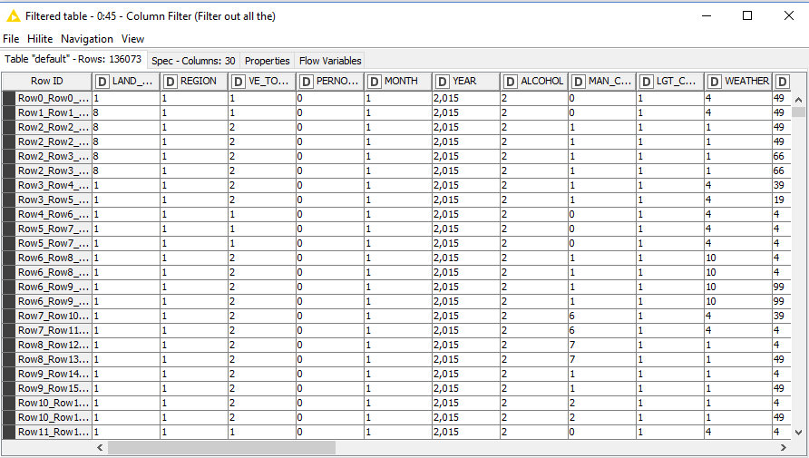After using column filter, we end up having only 30 columns, which we needed in our model.

Then we used Numeric Binner node to bin some of the categorical variables.

Using this node, we have binned 21 columns. These are – LAND_USE, REGION, ALCOHOL, MAN_COLL, LGT_COND, WEATHER, BODY_TYP, HAZ_PLAC, HAZ_REL, ROLINLOC, IMPACT1, DEFORMED, TOWED, SPEEDREL, VSURCOND, SEX, INJ_SEV, SEAT_POS, AIR_BAG, EJECTION, DRUGS.

We have binned our target column, INJ_SEV column.

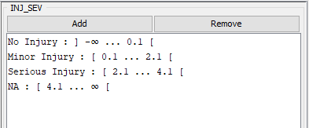

Based on our conditions, we have binned the INJ_SEV column to No Injury, Minor Injury, Major Injury and NA.

Similarly, we have binned other columns.

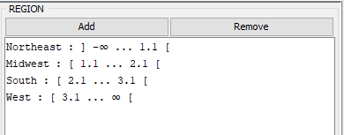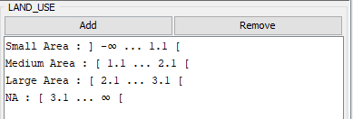Below are the details of those columns:

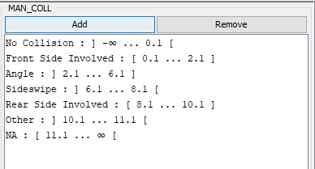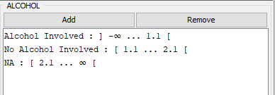

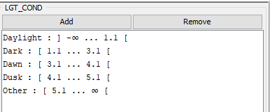

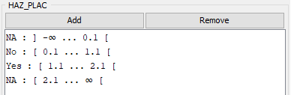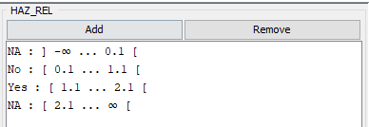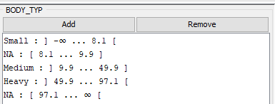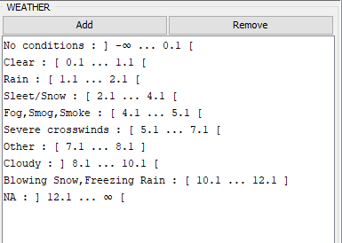

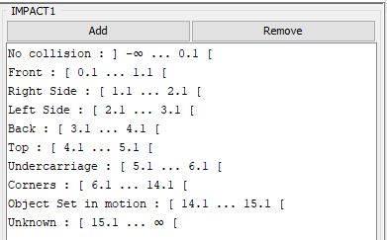

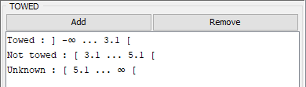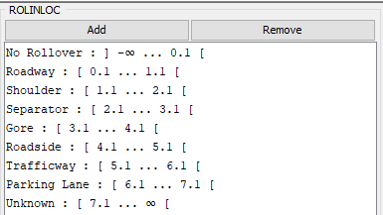

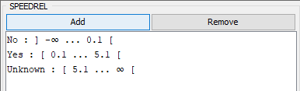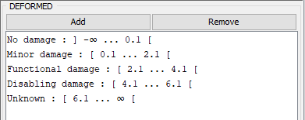

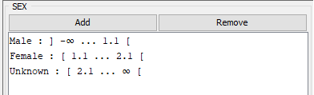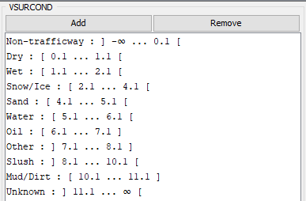

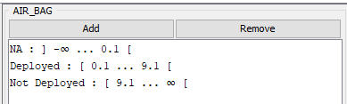

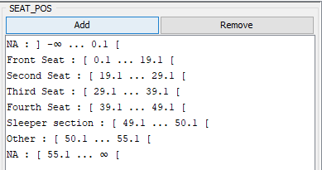

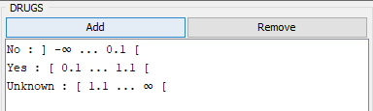

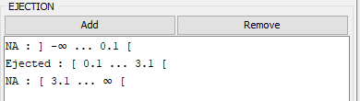

After binning all these columns, we have used another column filter to delete the original columns, which we have converted in the previous node in Numeric Binner.

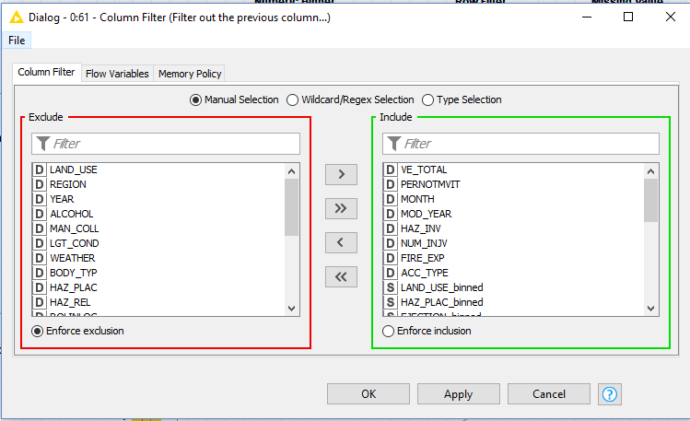

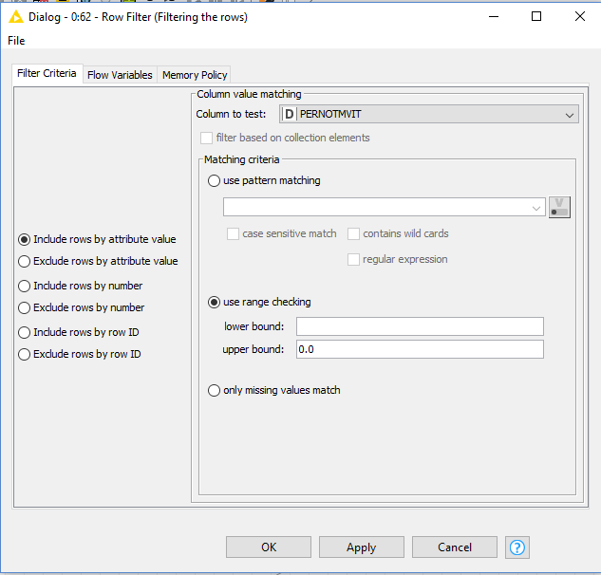We then used row filter node to filter out all the records where PERNOTMVIT = 0.

PERNOTMVIT column stands for not all the Number of persons was present in the motor vehicle. We do not want to include the persons who were not present inside the vehicle when accident happened.

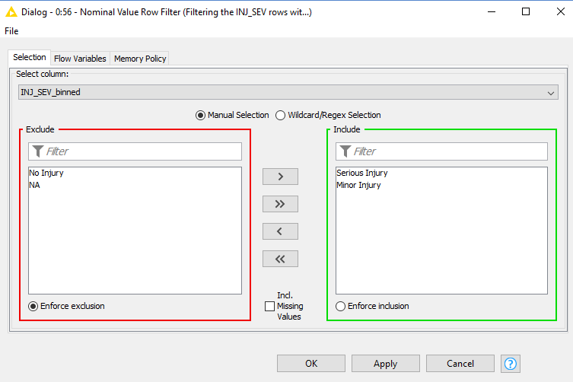

Then we used Nominal Value Row Filter node to not take into consideration of all the No Injury and NA records. We have simply excluded No Injury and NA ones in this node and only considered Minor and Serious Injuries.

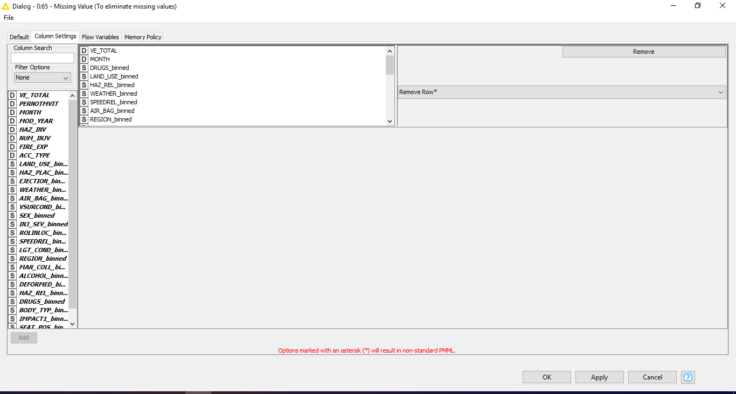

Then we used Missing Values node to remove all the rows where any of the columns contains missing value.

After doing all the pre-processing, we end up with 37715 Rows and 29 Columns.

Now we are going to build our models on this Cleaned data.

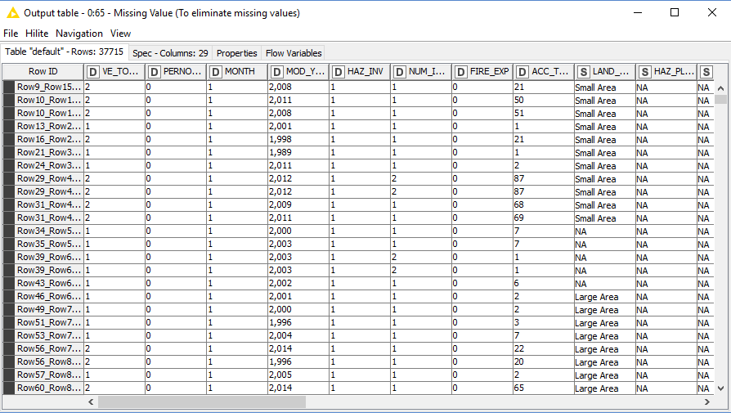

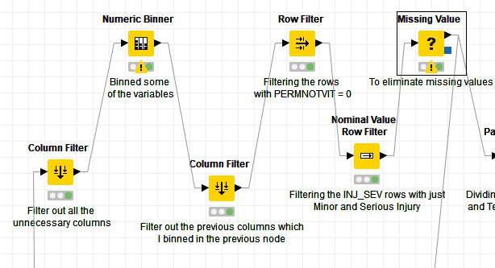 Here is the full Data Pre-processing flow:

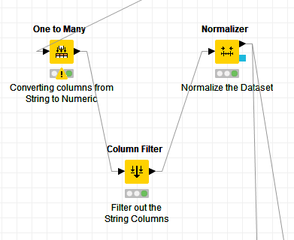For Artificial Neural Network (ANN), we have done couple of different Data Pre-Processing techniques, since ANN does not support Categorical variables and ANN need all its records to be normalized.

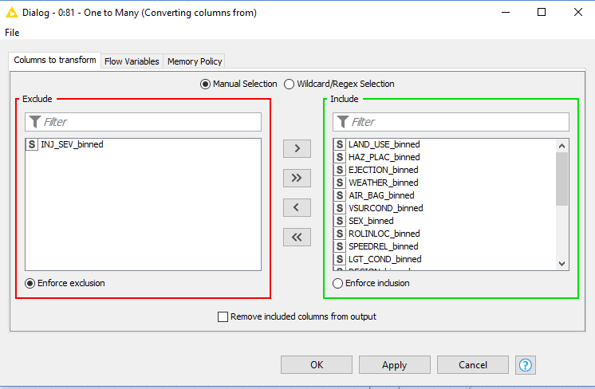

We have used one to Many Node to convert all the string columns to numeric ones.

We considered all the string columns in the Include part of the node, except INJ_SEV_binned column, which is our target variable.

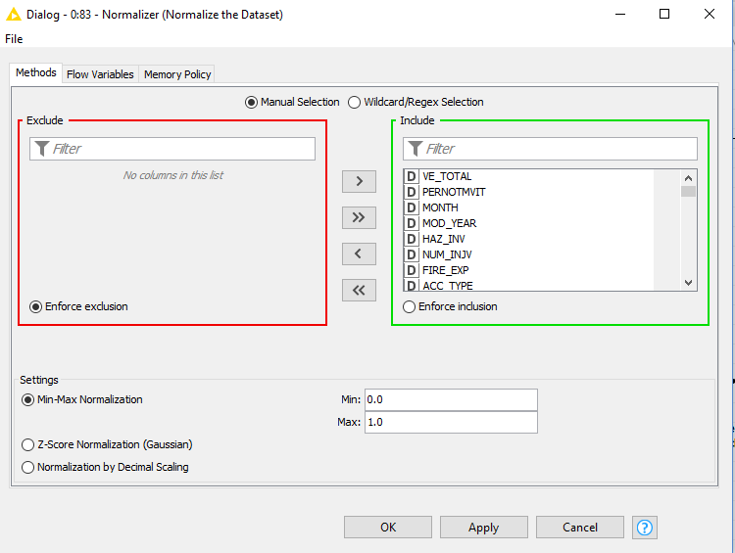

We then used Column filter node to exclude the string columns from our dataset.

Then we used normalizer to normalize all the values of the columns, so that we can use this data in our ANN Model.

# Model Building

Now that we have pre-processed the data to remove redundant variables (columns) and records (rows), performed numeric binning and calculated derived measure along with performing data splitting and SMOTE balancing, we will begin with model building phase. The distribution of the dependent variable is skewed on the minor injury category and so the data models would produce biased results. To get around this problem, we need to divide our dataset into training (70%) and testing (30%) sets and balance out the proportions of minority class vs. majority class in the training set by using SMOTE balancing technique which produces synthetic minority over-sampled records on the minority class.

We selected three prediction model for the purpose of classifying the variables important to us and also predicting the severity of the variables. The three model we will be working on are,

* Decision Tree
* Random Forest
* Artificial Neural Network

## Decision Tree

We used Decision Tree for the sole purpose of classification and know on which variables and on what values does our prediction splits on.

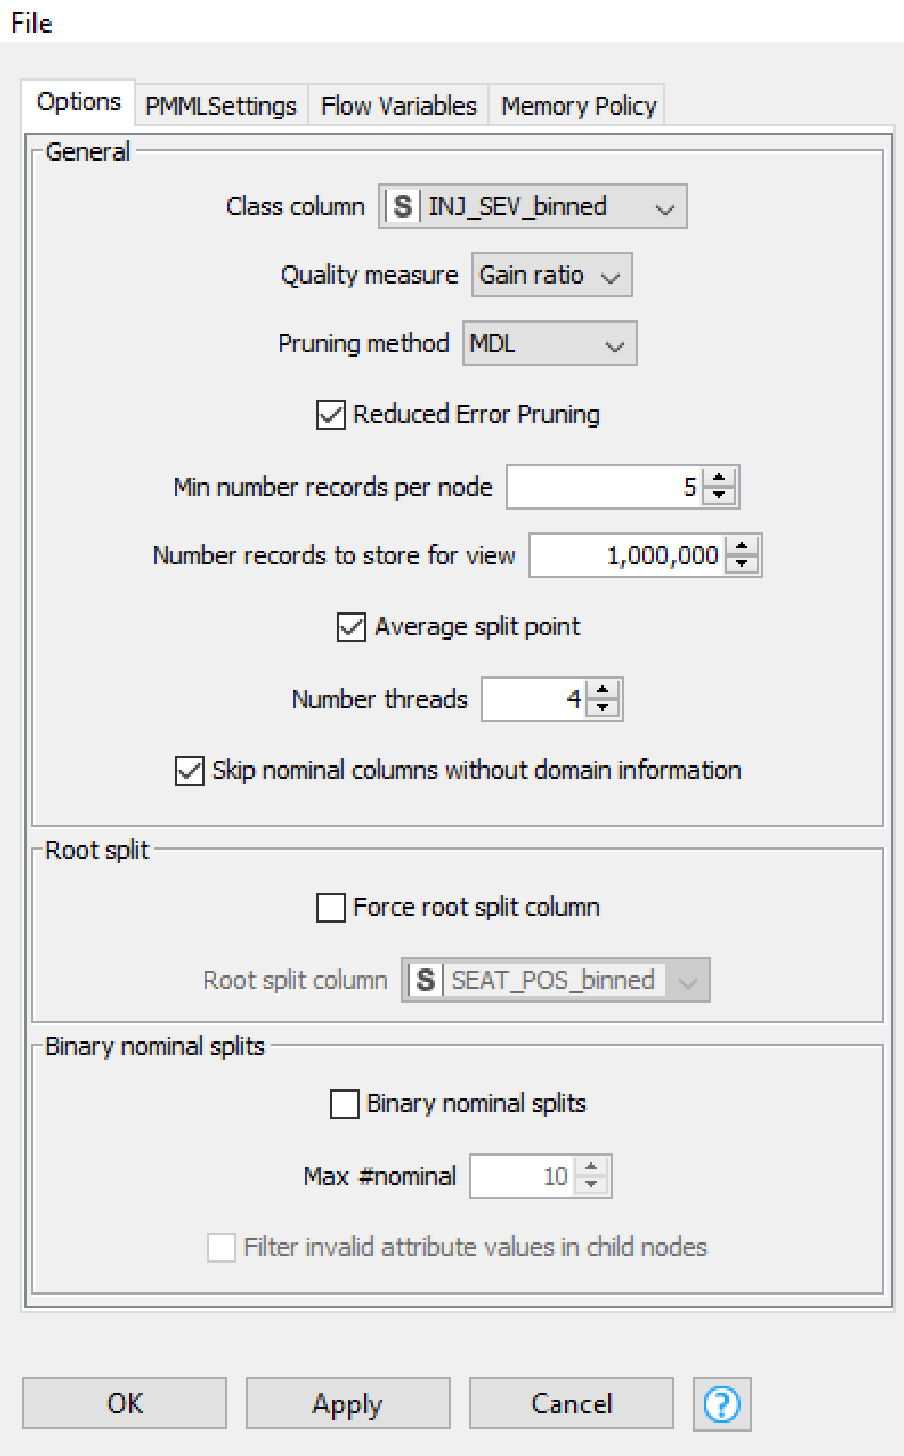

As shown in the figure above, we have chosen INJ_SEV_binned as the predictive class column with Gini Index as the splitting criterion or quality measure which measures the inequality among the nodes. We have chosen the minimum number of records per node to be default as we have enough data for our classification problem. The figure below also shows the Decision Tree Predictor Configurations which has been set to undergo normalized class distribution with the appended columns having predicted probabilities for both categories.

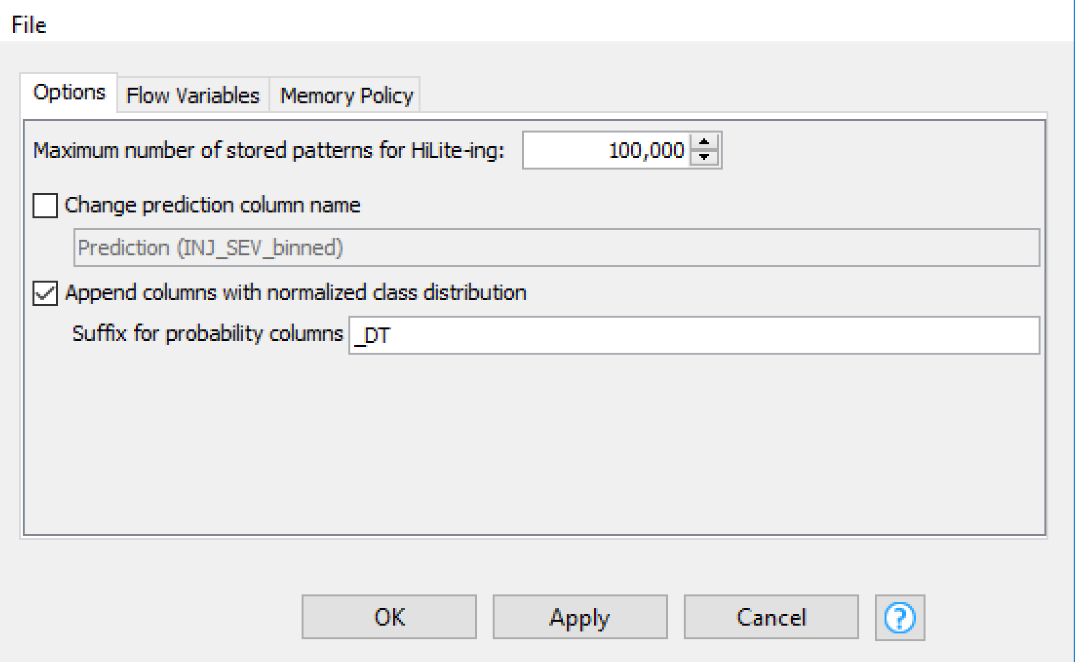

The Decision Tree obtained after running the cross validation is shown below,

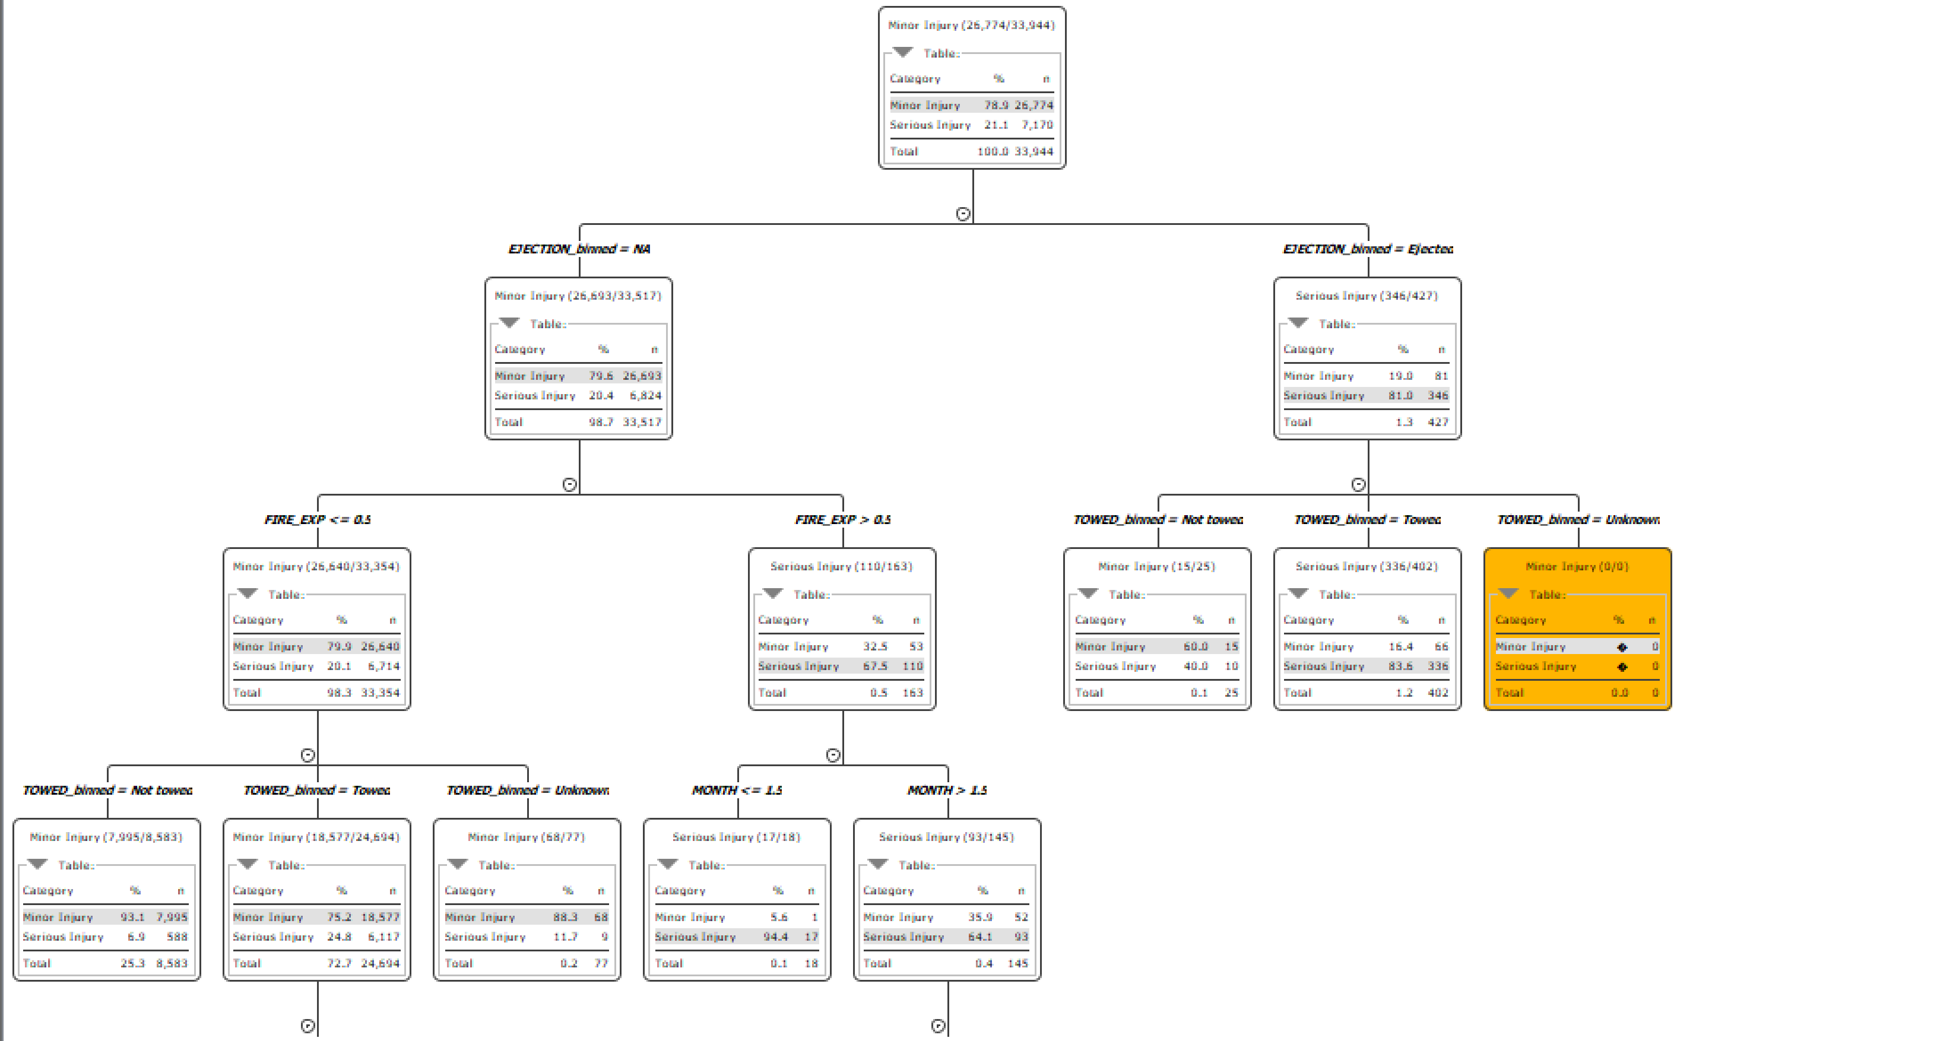

As we can see, Ejection, towed, month and fire exp are few of the deciding factors for injury severity during a car crash and thus by tweaking the safety regulations for both the car and highway we can bring the injuries down by significant margin.

Now we look at the accuracy statistics and confusion matrix of our model to see how well our model performed.

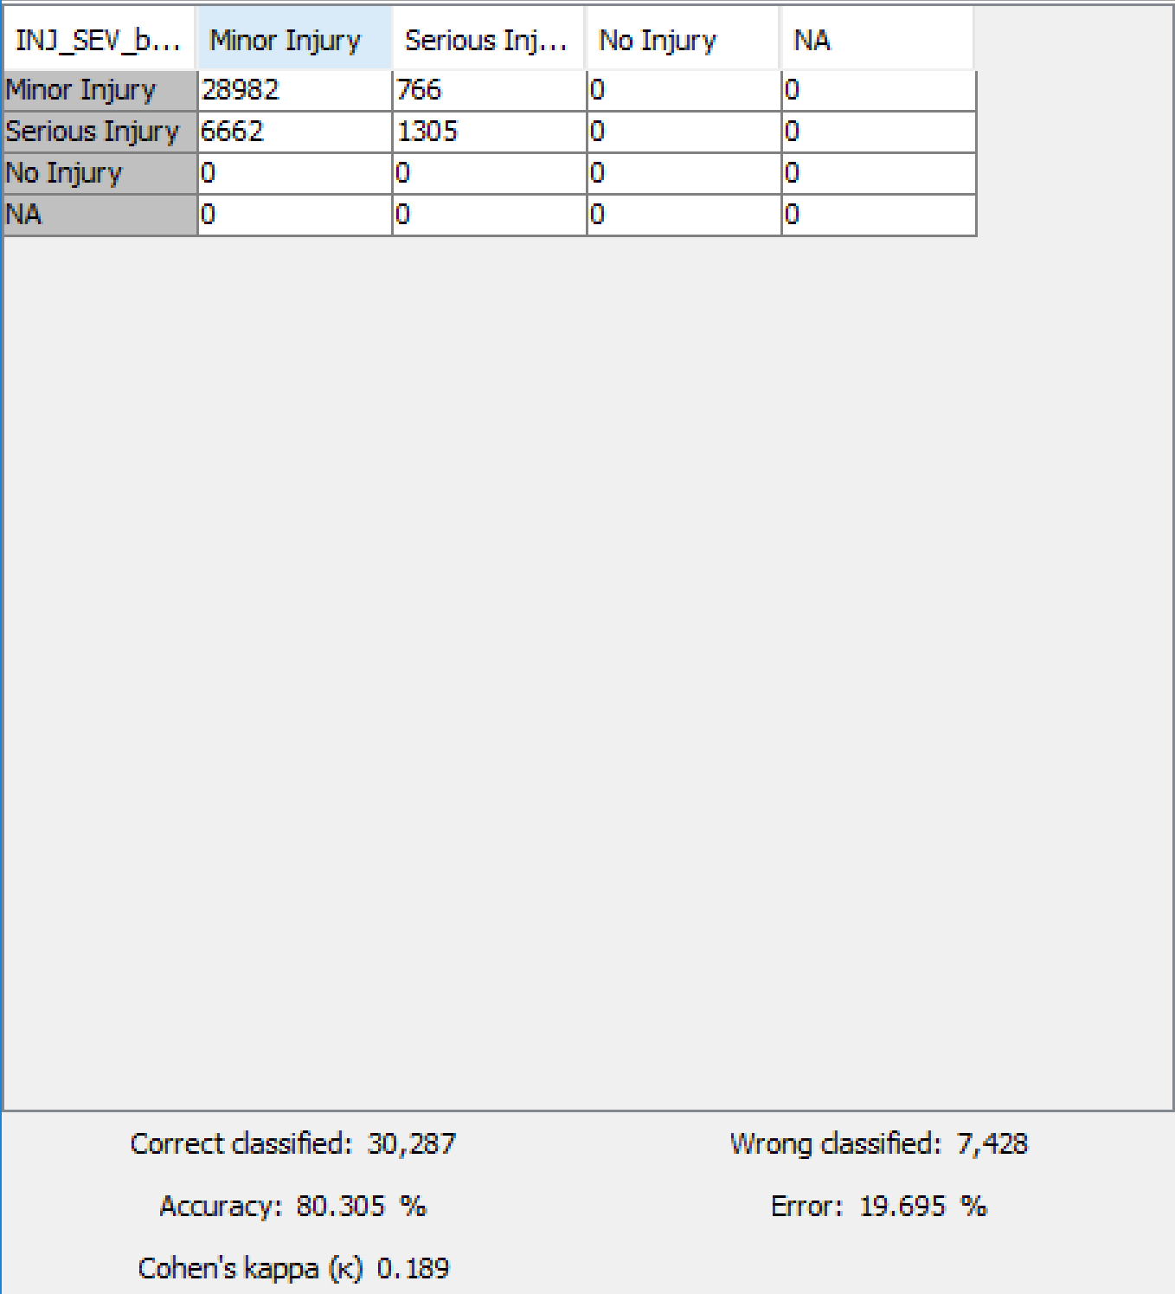

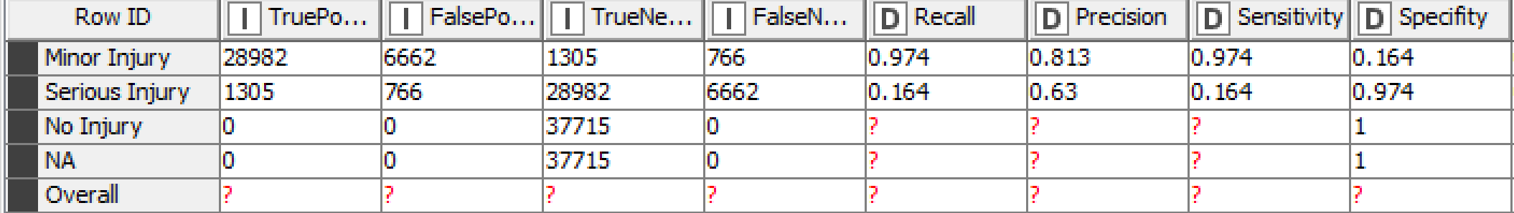

Looking at the accuracy, our model did performed well but the amount of False Negative detacted was high. Also the recall is low and thus there may be overfitting of the parameters.

## Random Forest

To counter the disadvantage of overfitting in decision tree, we ran the random forest model.

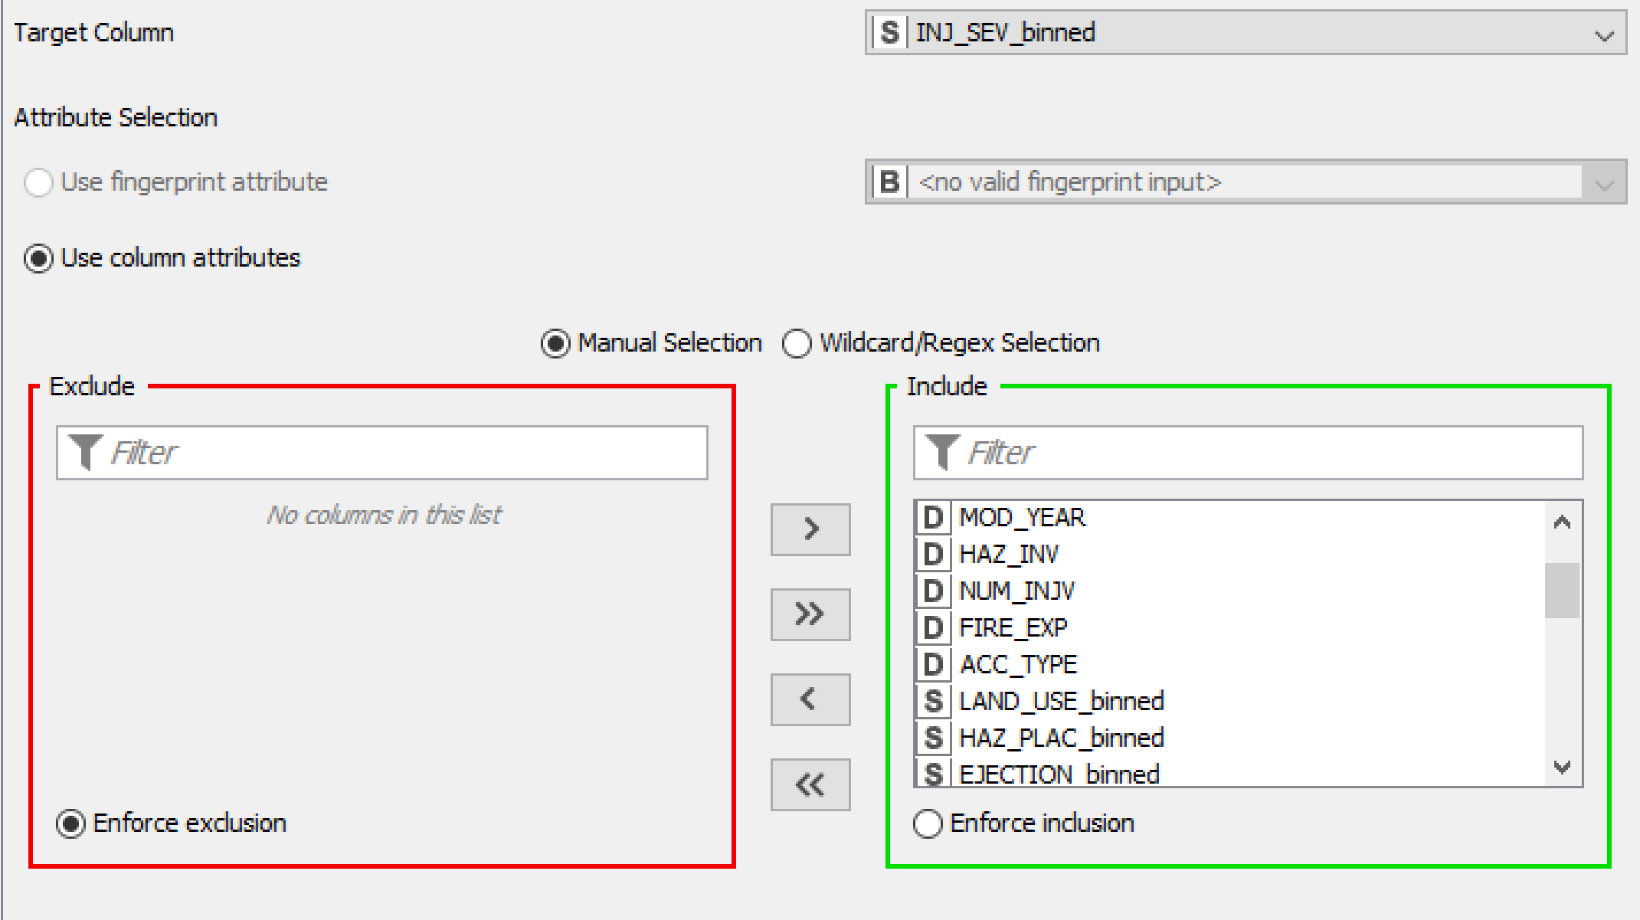

As shown in the figure above, we have chosen INJ_SEV_bineed as the predictive class column with Gini Index as the splitting criterion or quality measure which measures the entropy and consequently the uncertainty for choosing the splitting variable. We have chosen the number of trees in the forest to be 100 as we have enough data for our classification problem. The Figure shows the Random Forest Predictor Configurations which has been set to undergo normalized class distribution with the appended columns having predicted probabilities for both categories.

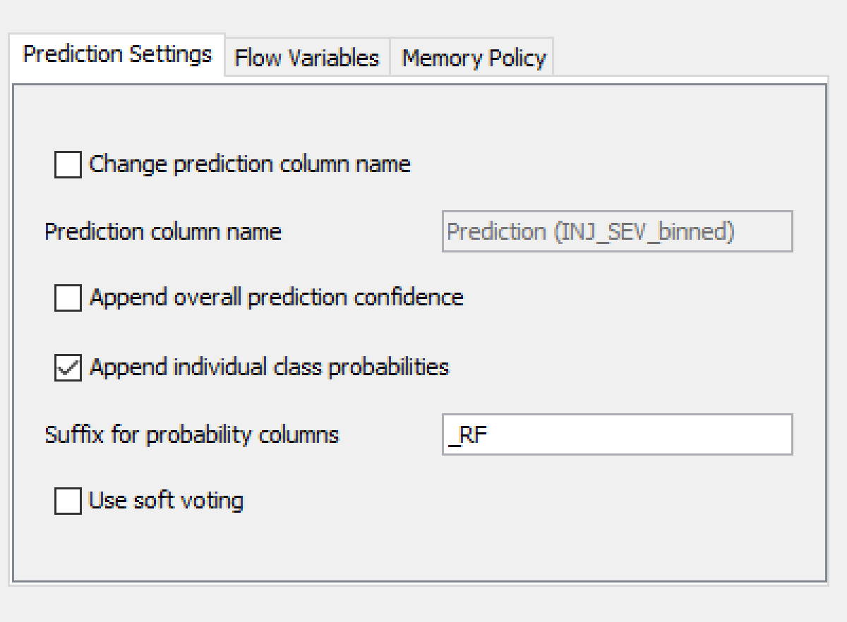

The scorer shows that the model is predicting the severity accurately. The Random Forest model still has tolerable false negatives for severe injury and a good overall accuracy compared to MLP and Decision Tree models.

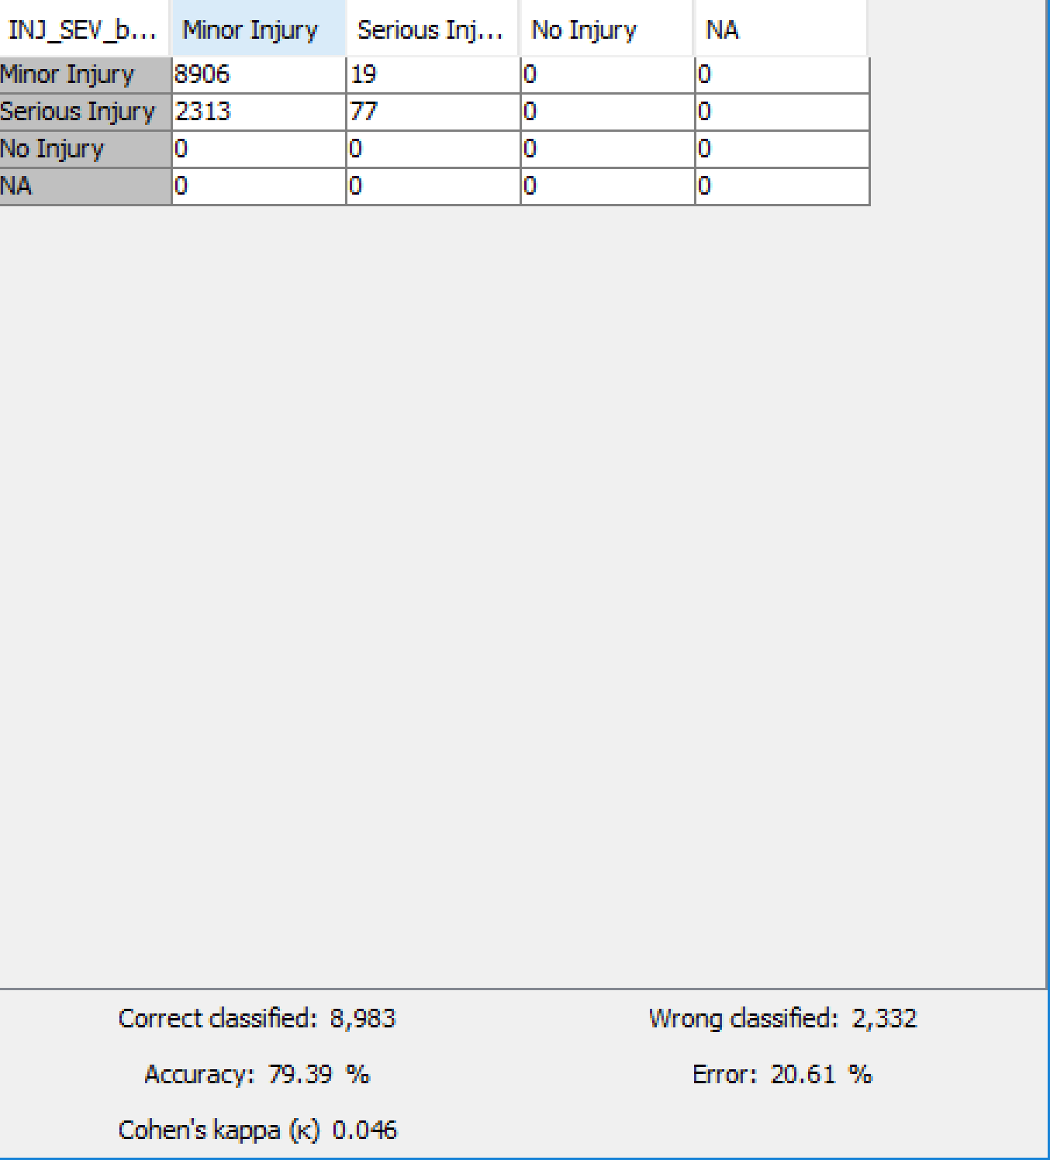

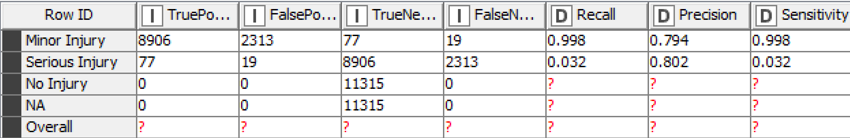

The figure below shows the attribute statistics (variable importance) of the generated Random Forest model. The table shows that VE_TOTAL (total number of vehicles involved in the accident) variable was selected as a candidate for splitting the root node 26 times out of the 100 decision trees built. It was the splitting variable 21 times out of the 26 times it was chosen. Similarly, the LGTCON (light condition during the crash) variable was a candidate for splitting the root node 18 times out of which it was selected 18 times. The other important splitting variables are FIRE_EXP (whether fire was involved in the crash) and ALCHL (whether alcohol was involved in the crash).

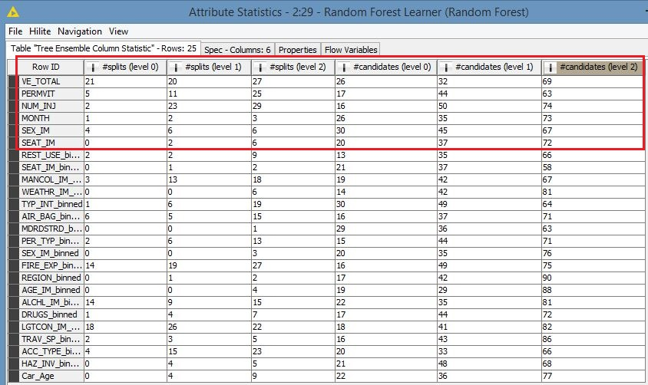

## Artificial Neural Network

For our prediction model, we decided to run neural network since all our variables are numeric. We will have to prepare the data before importing the data to the MLP Learner & Predictor. Since, MLP Learner and Predictor only accepts double columns, we will have to use One to Many conversion, since many binned variables have multiple categories. Moreover, MLP Learner and Predictor also only accepts normalized variables, so we need a Normalizer node for converting the variables into a range of 0 to 1 using Min-Max Normalizer.

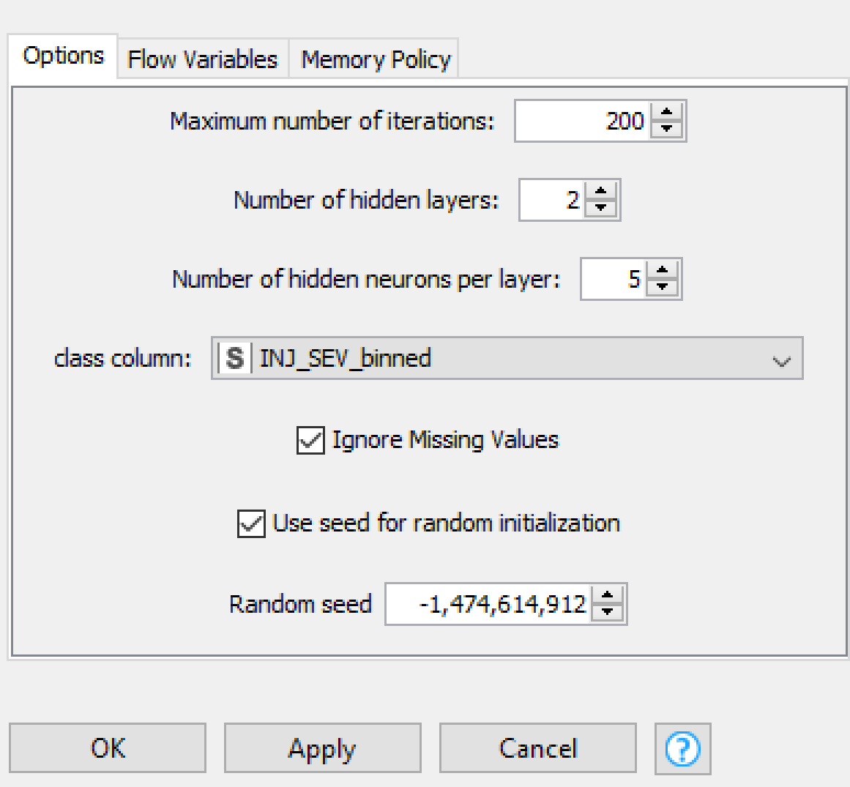 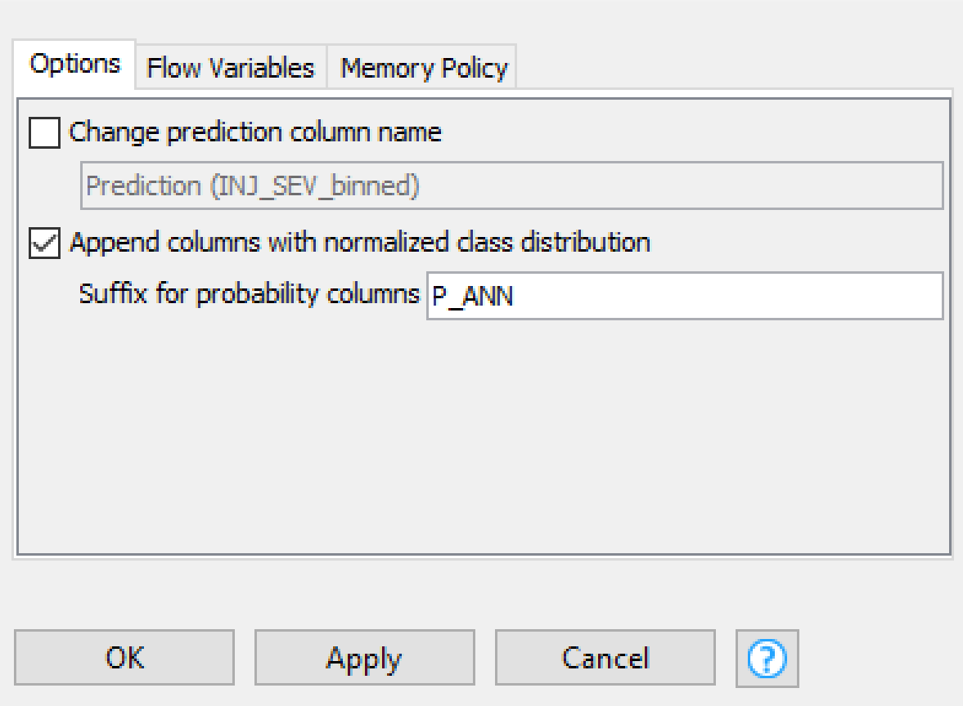

After modeling, we infer the accuracy statistics,

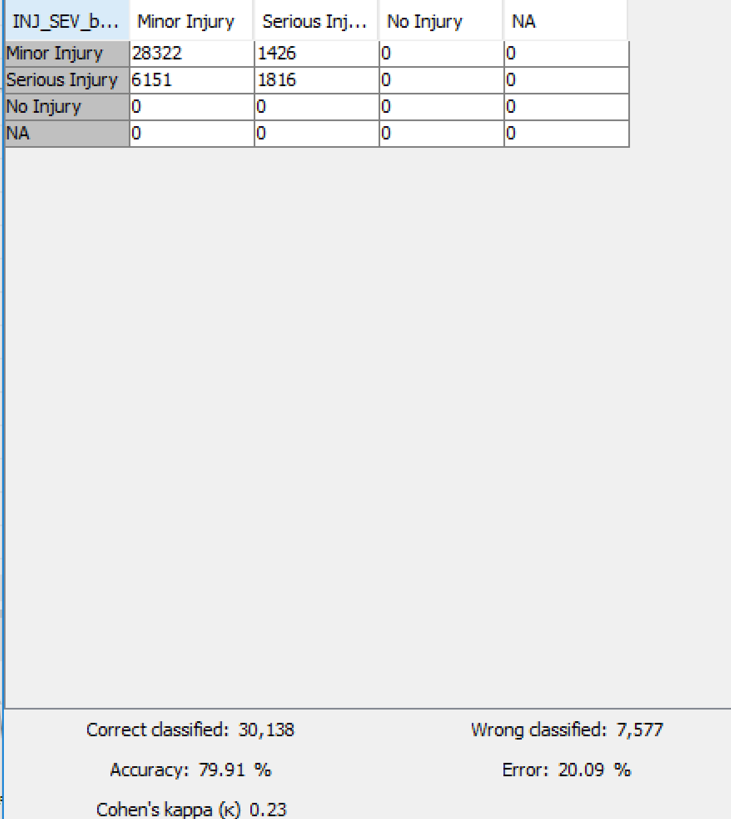

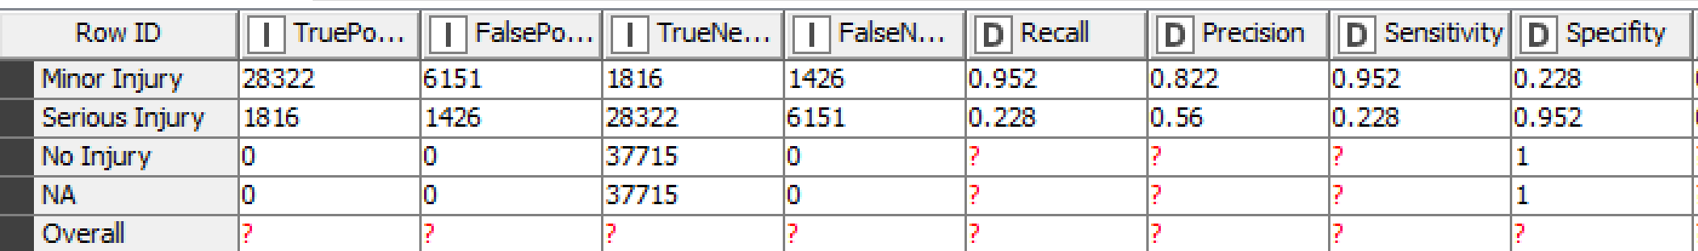

The MLP model has high false negatives for severe injury but a high overall accuracy and also the recall is best out of all the models.

# Model Assessment

After building predictive models the most important thing is to assess and validate the models and go back and do revisions to the models to ensure better performance. Initially the models were built using single splits with balancing done involving under sampling for minority classes. Accuracy was checked and in order to improve accuracy we went with 10- fold cross validation to ensure better quality predictions the following screens will show the difference in accuracy using the two techniques.

 

Cross validation and single split accuracy results for decision tree.

 

Cross validations and single split accuracy results are as shown above for the MLP.

The accuracy on the right is after 10-fold cross validation and the one one the left is using single test split. And we can clearly see that the neural network and decision tree perform better in terms of accuracy after cross validation as compared to single split. No 10-fold cross validation was performed on the Random forest as it performs internal cross validation on every tree it builds and following is the accuracy of the random forest.



The random forest performs well with an accuracy of 79.3% which is very good on a single split of data as compared to 10-fold cross validation of the neural network and decision tree.

Another way of assessing the models is by using ROC curves which are as shown below for all the models.





From the ROC curves we can see that the that for both the classes the models perform well in prediction than the random chance model which could be built along the 0.5 random walk line.

# Model Deployment

As the Model Assessment suggests, some of our models were quite robust and were able to predict injury severity. These models can be put to recurring use, provided data is collected on these data points consistently. More variables can be included in the future with expanding data sets. Barring the artificial neural network, our other models allow us narrow down several causes and aftermaths of severe injuries. We suggest two deployment scenarios based on causes and aftermaths that our models deem to be important. The two scenarios are:

1. Optimizing Infrastructure
2. Deploying EMT resources

## Optimizing Infrastructure

The road transportation industry is bracing for a change in paradigm with introduction of self-driving vehicles. The rising popularity of Tesla, Uber and most industry leader’s initiatives point towards a more autonomous future for road travel. It can be argued that in future, humans will have less control over their vehicles. It is thus, consequential for our road infrastructure to be designed specifically to keep the transportation safe, without any human interference. From our random forest model, we separated human and non-human or physical factors according to their variable importance. These factors are listed in table 1 below.

|  |  |
| --- | --- |
| Physical Factors | Human Factors |
| 1. Body Type 2. Light Condition 3. Region 4. Weather 5. Month 6. Population | 1. Alcohol 2. Drugs 3. Gender 4. Speed |

Table 1: Physical and Human Factors

Our analysis shows that more car crashes can be predicted based on body type of the car, the light conditions, the region, weather, month of travel, and population. Based on this information, we can categorize these factors according to their related attributes into three major findings: first, some body types of cars tend to cause more severe injuries to their passengers during crash than others. The car manufacturers must optimize and run thorough testing on the body types that is more prone to accidents. Second, Light conditions, weather and month of travel are related variables and warrant more attention from both infrastructure authorities and car manufacturers to make the cars more sensitive to certain light and weather conditions and infrastructure more resilient to these conditions. Third, the region and population shows some core flaws with the infrastructure and density of road environments. The root cause of these flaws must be studied and appropriate measures should be taken to ensure road safety.

## Deploying EMT resources

Emergency Medical Technicians (EMT) are one of the critical first respondents in event of a car accident. Since our models attempt to predict injury severity, we have not eliminated the subsequent events after the accident to generate insights for optimal deployment of EMT resources. We identify factors that lead up to a severe injury and the ones that follow it. Based on these recent factors, the first responders training can include the level of preparedness for the accidents that had elevated severity in injury and the resources can be limited comparatively. From our random forest model, we separated antecedent and subsequent factors according to their variable importance.

|  |  |
| --- | --- |
| Antecedent | Subsequent |
| 1. Alcohol 2. Body Type 3. Drugs 4. Light Condition 5. Speed 6. Region | 1. Towed 2. Ejection 3. Deformed 4. Manner of Collision 5. Air Bag |

Table 2: Antecedent and Subsequent Factors

Based on the above variables, the antecedent factors can also be categorized. Alcohol, Drugs and Speed are a part of recklessness and intoxication. These factors cannot be controlled by authorities apart from raising awareness. However, factors like the body type, drugs, light condition, speed, and region can be used to strategically make allocate the EMT resources. Similarly the subsequent factors such as towed, ejection, deformed, manner of collision, and air bag can help allocate resources based on the information included in distress calls after the crash has occurred.

## Final Workflow

